**1)** **Write a query to get data having length of Rna structures more than 12 with them being added after 2008.**

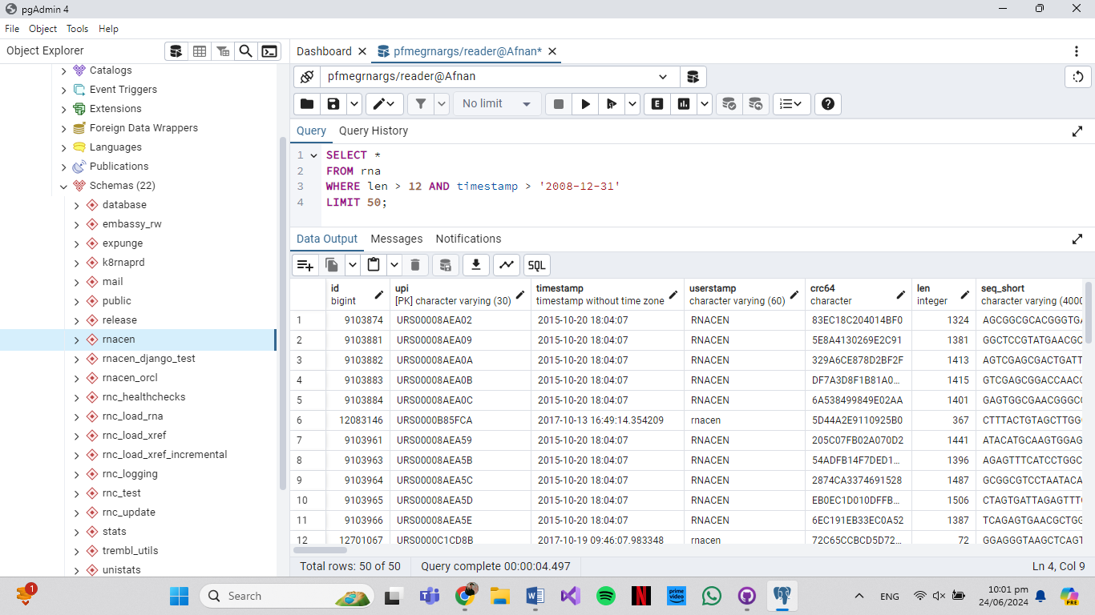

**2)**  **How many pre computed RNA are present that are still active and got their last release update before 2022**

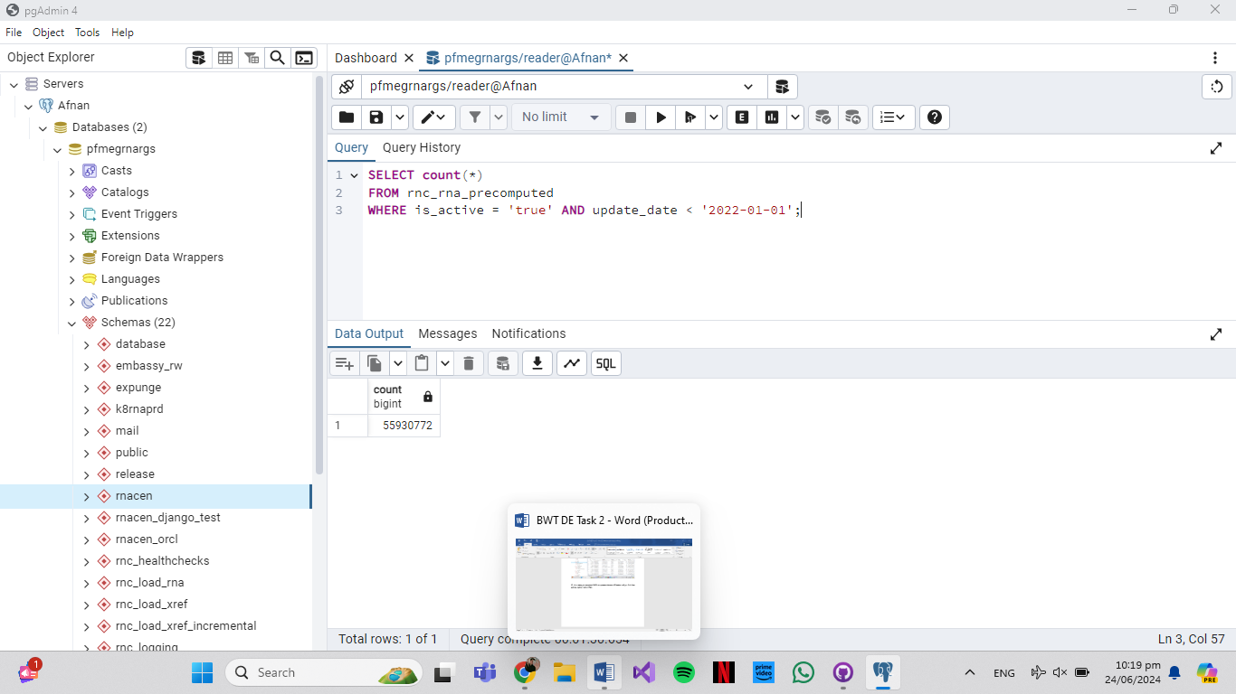

**3)** **How many total pre computed RNA records for snoRNA and tRNA were recorded in 2011, 2016, 2014, and 2020** .

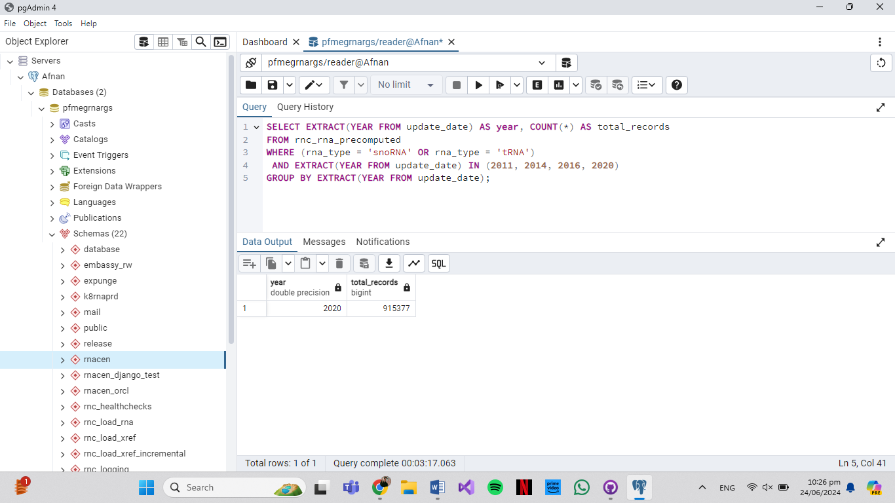

**4) Can you give me the names of all databases built for RNA with minimum length other than 100, 200, 300, 400, and 15**

